EXPERIMENT 7
INTEGRATION OF ADVANCED ANALYTICS WITH BI REPORTS USING MICROSOFT POWER BI
1. AIM
To integrate advanced analytics with Business Intelligence reports using Microsoft Power BI and generate business insights, strategic recommendations, and executive presentations that support organizational decision-making.
2. OBJECTIVES
- To analyze existing Power BI reports and dashboards created in Experiments 5 and 6.
- To examine sales performance by region, profitability by product category, and customer segment performance.
- To analyze monthly and yearly sales trends and document significant observations.
- To identify business strengths, weaknesses, and opportunities using charts, KPIs, and analytical evidence.
- To prepare a Business Insight Report containing key findings and recommendations.
- To communicate findings through a professional executive presentation.
3. TOOLS / SOFTWARE REQUIRED
- Microsoft Power BI Desktop
- Global Superstore Dataset.xlsx
- Power Query Editor
- Microsoft PowerPoint
4. DATASET USED
Global Superstore Dataset.xlsx. Dataset source: Kaggle – https://www.kaggle.com/datasets/apoorvaappz/global-super-store-dataset
5. THEORY
Advanced Analytics in Business Intelligence focuses on transforming data into actionable insights. Traditional BI reports present information, while advanced analytics helps identify trends, opportunities, business challenges, and improvement areas.
Power BI supports advanced analytics through KPI analysis, trend analysis, comparative analysis, ranking, segmentation, and interactive reporting.
Business strengths are areas where the organization performs well. Weaknesses are areas that limit performance or profitability. Opportunities are potential areas for improvement or growth.
Analytical findings should be supported by report visuals, KPI values, comparisons, and trends. These findings can then be converted into practical business recommendations for management.
6. PROCEDURE
Part A: Analyze Existing Reports and Dashboards
Step 1: Open Microsoft Power BI Desktop.
Launch Power BI Desktop from the Start menu or desktop shortcut.
Step 2: Open the reports and dashboards created in Experiments 5 and 6.
Select File > Open report and browse to the saved .pbix file, or open the recent report from the start screen.
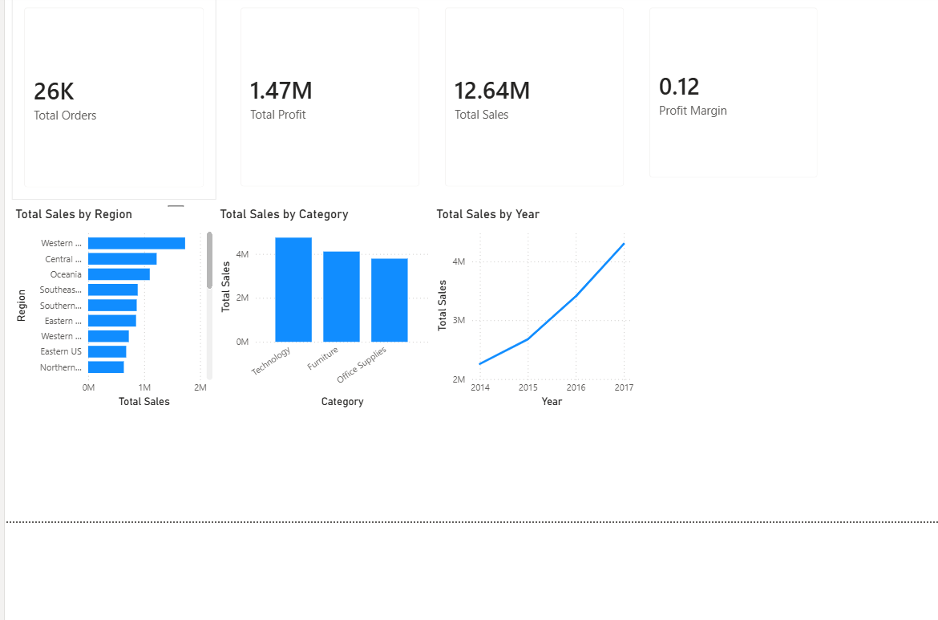
Step 3: Analyze Sales Performance by Region.
Select the visual that displays Sales by Region. Compare the sales values across all available regions.
Record the region with the highest sales and the region with the lowest sales, based on the displayed values.
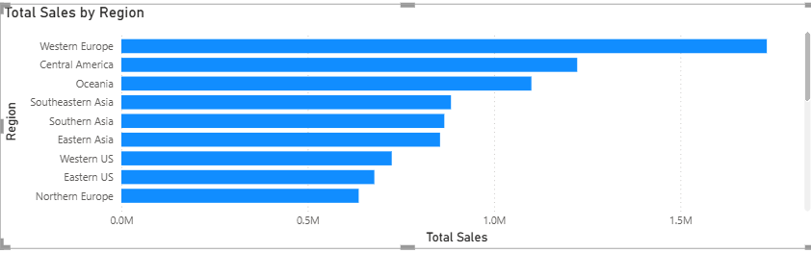
Step 4: Analyze Profitability by Product Category.
Review the profit or profit-by-category visual. Compare the categories and note which category contributes the most and least profit.
Use the actual values shown in the report; do not assume that the category with the highest sales also has the highest profit.

Step 5: Analyze Customer Segment Performance.
Review the sales and/or profit visual for customer segments.
Compare the performance of each segment and note important differences in sales, profit, or order contribution.
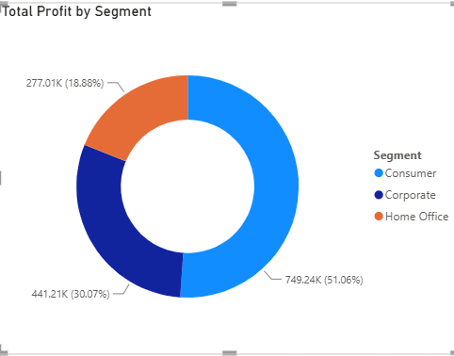

Step 6: Analyze Monthly and Yearly Sales Trends.
Review the monthly sales trend and yearly sales comparison.
Identify periods of growth, decline, seasonal variation, or unusual changes where visible.
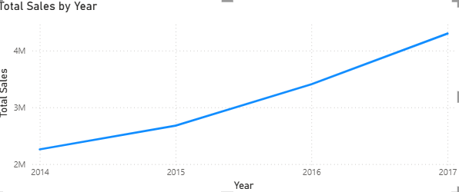
Step 7: Document significant observations.
Write concise observations from the visuals reviewed in Steps 3–6. Include the metric, the relevant region/category/segment/period, and the evidence shown by the report.
Part B: Business Problem Identification
Step 8: Identify at least two business strengths.
Use the report evidence to identify two areas of positive performance. Examples may include strong regional sales, profitable categories, or a customer segment contributing significant sales. Confirm each strength using the dashboard.
Step 9: Identify at least two business weaknesses.
Identify two performance concerns supported by the report, such as low sales in a region, weak category profitability, or a segment with relatively low contribution. Use the displayed figures to support each point.
Step 10: Identify at least two business opportunities.
Use the findings to identify two possible improvement areas, such as improving performance in a low-performing region, reviewing category pricing or costs, or strengthening customer-segment performance.
Step 11: Support findings using charts, KPIs, and analytical evidence from Power BI.
For each strength, weakness, and opportunity, note the relevant chart or KPI and the value or comparison that supports the finding. Avoid unsupported assumptions.
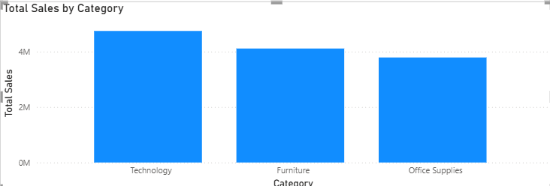
Part C: Business Insight Report Preparation
Step 12: Prepare a Business Insight Report.
Create a Word document and organize it using the sections below. Keep the writing concise, professional, and based on the actual dashboard findings.
- Objective of Analysis
- Reports and Dashboards Used
- Key Findings
- Business Strengths
- Business Weaknesses
- Opportunities for Improvement
- Recommendations
- Conclusion
- 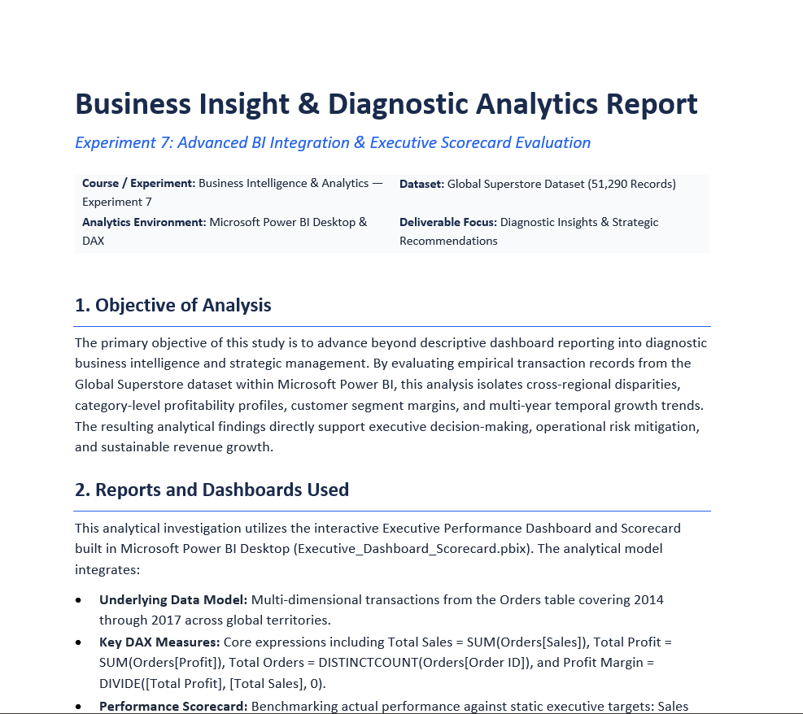
Step 13: Include screenshots from Power BI reports and dashboards.
Insert relevant screenshots near the findings they support. Add a figure number and caption to each screenshot. Ensure chart titles and values are readable.
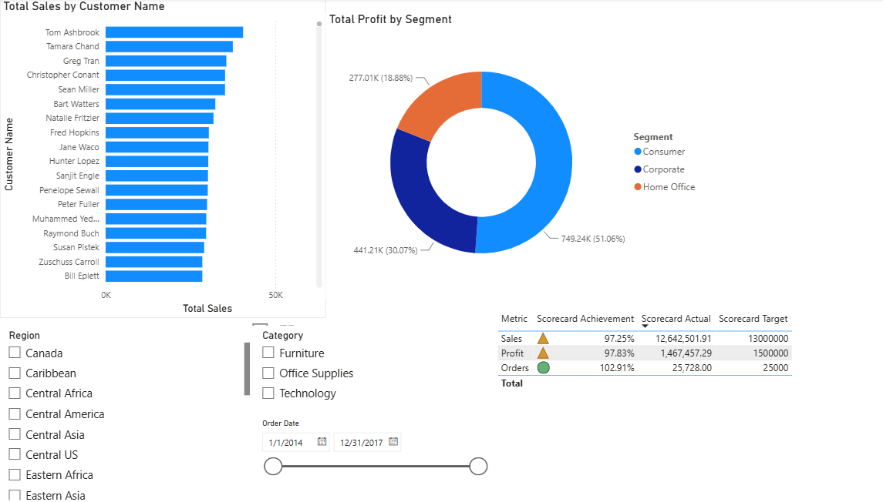
Step 14: Write evidence-based recommendations and a conclusion.
For every recommendation, state the business issue, the evidence observed, and the action management could take.
In the conclusion, summarize the main findings and explain how the analysis can support decision-making.
Part D: Executive Presentation
Step 15: Prepare a presentation consisting of 5–7 slides in Microsoft PowerPoint.
Open PowerPoint and create a new presentation. Use a clear, consistent theme and readable text.
Step 16: Create the presentation slides using the suggested structure.
Slide 1: Introduction and objective of analysis
Slide 2: Dashboard overview and KPIs
Slide 3: Key findings and performance trends
Slide 4: Business strengths and issues identified
Slide 5: Opportunities and recommendations
Slide 6: Conclusion (and optional supporting evidence slide)
Step 17: Add supporting charts and evidence.
Insert selected dashboard screenshots or recreate essential charts in PowerPoint. Include short captions and highlight the figures that support each key message.
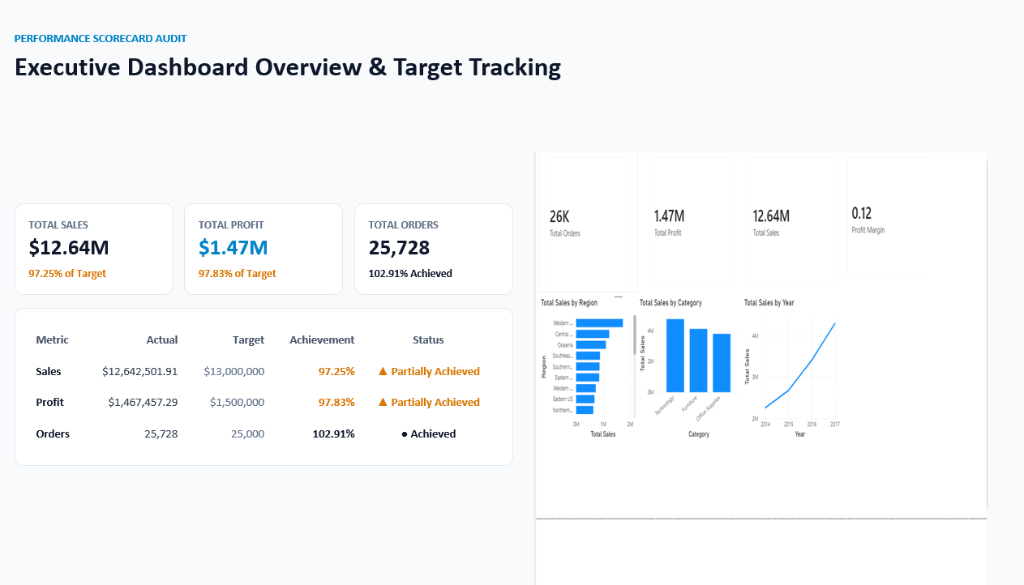
Step 18: Present findings before the instructor or class.
Explain the purpose of the analysis, the most important findings, and the recommendations. Keep the presentation within the required 5–7 slide format.
Step 19: Justify recommendations using data-driven evidence.
For each recommendation, refer to the relevant KPI, chart, trend, or comparison. Clearly distinguish observations from suggested actions.
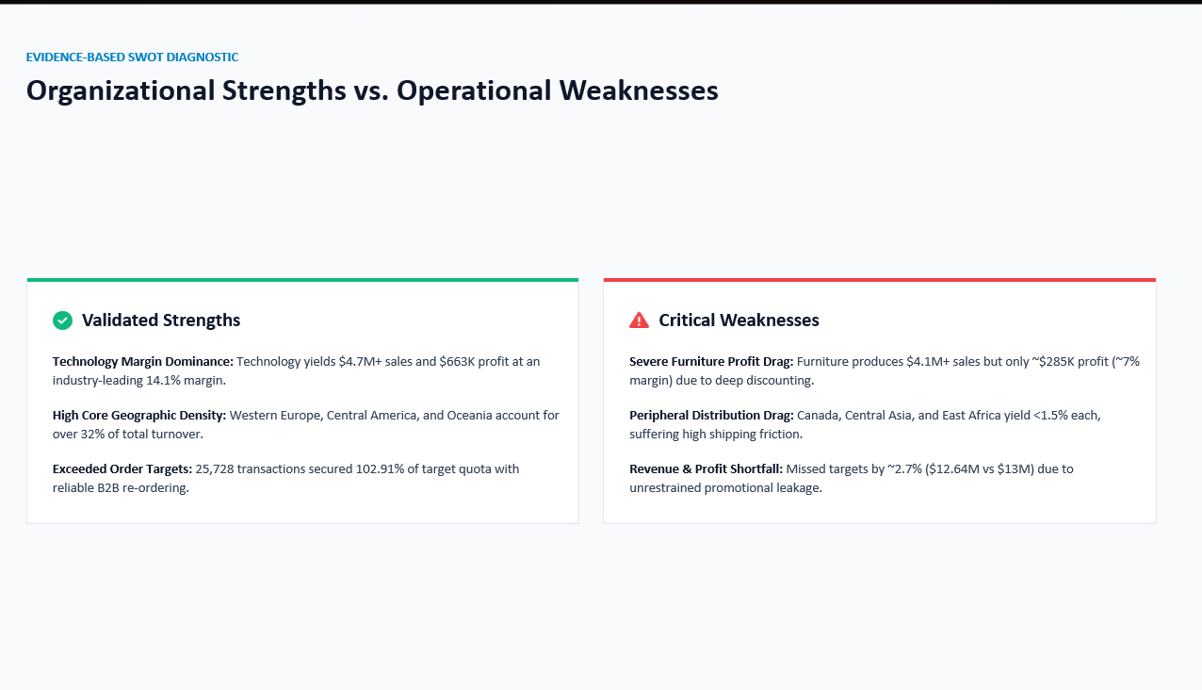
Part E: Final Review and Deliverables
Step 20: Review the Business Insight Report.
Check that all required sections are included, the screenshots are readable, and the findings match the Power BI report.
Step 21: Review the Executive Presentation.
Confirm that the presentation contains 5–7 slides, has a clear sequence, and includes evidence for the recommendations.
Step 22: Prepare the final deliverables.
Business Insight Report (PDF/Word)
Executive Presentation (PPT/PDF)
Recommendation Summary Sheet
Supporting Power BI Dashboard (.pbix)
Step 23: Prepare a Recommendation Summary Sheet.
Summarize each recommendation in a short format: identified issue, supporting evidence, recommended action, and expected business benefit.
7. RESULT
Advanced analytics techniques were integrated with Business Intelligence reports and dashboards. Business strengths, weaknesses, opportunities, and recommendations were identified using Power BI evidence and communicated through a Business Insight Report and executive presentation.
8. LEARNING OUTCOMES
- Applied advanced analytical techniques to business reports and dashboards. (CO3-BT3)
- Analyzed organizational performance using BI tools and KPIs. (CO3-BT4)
- Generated business insights from analytical findings. (CO5-BT6)
- Developed strategic recommendations based on data-driven evidence. (CO5-BT6)
- Communicated analytical findings through professional reports and presentations. (CO5-BT6)
9. TEXT / REFERENCE BOOKS
- Sharda, Delen & Turban, Business Intelligence and Analytics.
- Cindi Howson, Successful Business Intelligence.
- Ralph Kimball & Margy Ross, The Data Warehouse Toolkit.
- Microsoft Power BI Official Documentation.

